**Dynamic CVE Data Retrieval Functionality**

**Introduction:**

The project commenced with accessing the National Vulnerability Database (NVD) Common Vulnerabilities and Exposures (CVE) API, aiming to fetch, store, and present CVE data efficiently. Utilizing Flask APIs, a user-friendly web interface was crafted, facilitating seamless interaction with the CVE data.

**Challenges Faced:**

**Huge Data Handling**

* Managing the extensive dataset from the NVD CVE API, comprising thousands of vulnerability entries, posed significant challenges.
* Efficient storage and processing mechanisms were imperative to handle the vast amount of data effectively.
* Due to API limitations, data processing was initially constrained to a manageable subset, requiring careful consideration of data selection criteria.

**Technical Constraints:**

* Hardware limitations, including CPU, memory (RAM), and storage capacity, impacted the project's ability to handle and process data efficiently.
* Compatibility issues with development tools and frameworks necessitated thorough evaluation and adaptation to ensure seamless integration and performance optimization.

**Process I Approached:**

1. **Data Retrieval: APIFetcher.py**

**Purpose:**

* Orchestrates the retrieval of data from the NVD CVE API, ensuring robust connectivity and data integrity.
* Implements strategies to manage data retrieval efficiently, such as batch processing and error handling mechanisms.

**Output:**

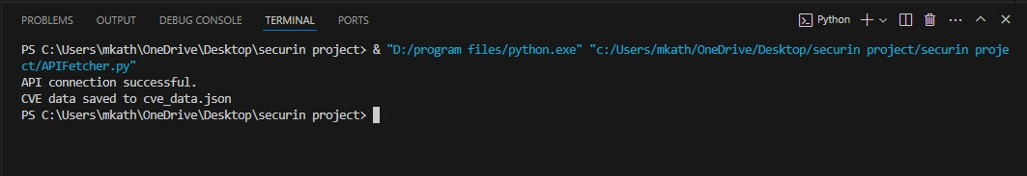

* Successful establishment of a reliable connection to the API endpoint.
* Implementation of data retrieval methods to overcome API limitations and optimize resource utilization.

1. **Database Storage: MongoStore.py**

**Purpose:**

* Facilitates seamless storage of fetched data into a MongoDB database, ensuring data integrity and accessibility.
* Implements efficient data insertion methods and database schema design to optimize storage and retrieval processes.

**Output:**

**My DB and collection name:** **CSW, test**

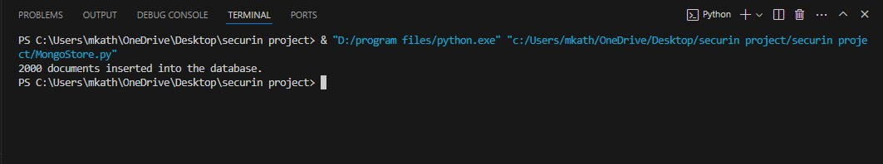

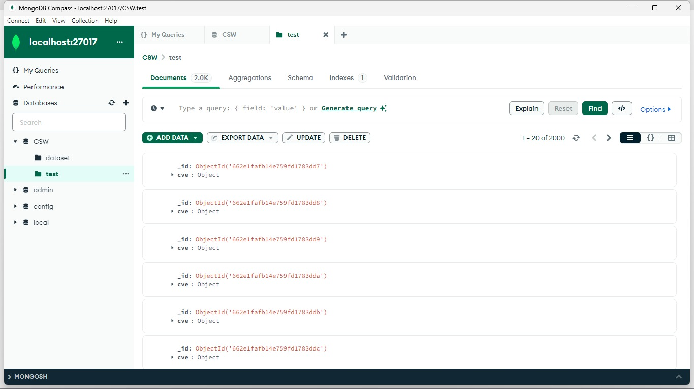

* Establishment of a connection to the MongoDB server and creation of the necessary database collections.
* Implementation of data insertion methods to efficiently store CVE data while maintaining database performance.

1. **API Generating for DB Data: app.py**

**Purpose:**

* Development of Flask APIs to interact with the MongoDB database, providing a robust backend for the web application.
* Defines API endpoints and routes to enable seamless data access and manipulation.

**Output:**

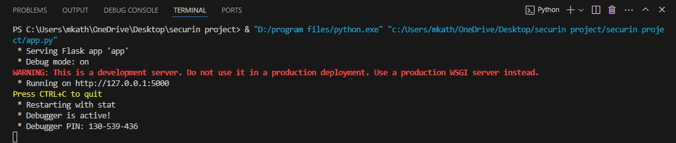

* Creation of APIs to handle CRUD (Create, Read, Update, Delete) operations on CVE data, ensuring data integrity and accessibility.
  + Implementation of authentication and authorization mechanisms to secure API endpoints and protect sensitive data.

1. **Table Page: index.html**

**Purpose:**

* Serves as the main interface for the web application, presenting CVE data in a structured and user-friendly format.
* Implements pagination controls and search functionality to enhance data navigation and exploration.

**CVE Data Retrieval Functionality:**

* **Description:** This JavaScript function retrieves detailed CVE information from the Flask API and then appended the data into the row.
* **Purpose:** By this only the data can be fetched from Api and then using the table head id the td rows are appended dynamically

**Output:**

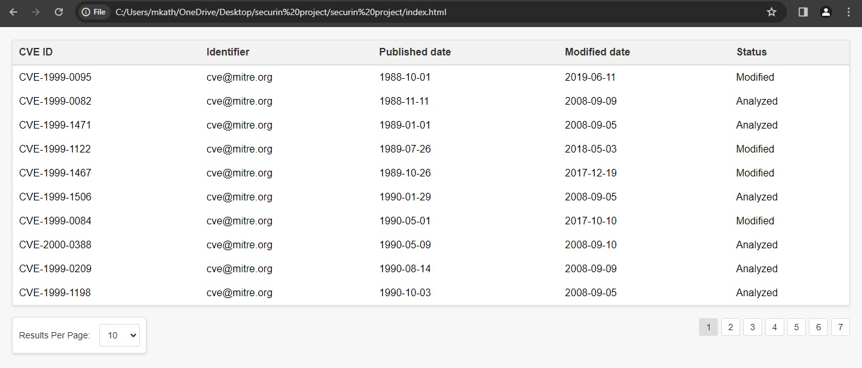

* Design and implementation of the main page HTML layout, incorporating responsive design principles for optimal user experience across devices.
* Integration of dynamic data rendering mechanisms to display CVE data retrieved from the backend APIs.

1. **Next page with details: details.html**

**Purpose:**

* Provides detailed information on individual CVE entries, enabling users to explore specific vulnerabilities in-depth.
* Implements interactive features and data visualization components to enhance user engagement and understanding.

**CVE Data Retrieval Functionality:**

* **Description:** This JavaScript function retrieves detailed CVE information from the Flask API based on the CVE ID passed from the main page HTML. It dynamically updates the content of the detailed CVE page with the fetched data.
* **Purpose**: Provides users with comprehensive information on specific CVE entries, enhancing their understanding and enabling informed decision-making.

**Output:**

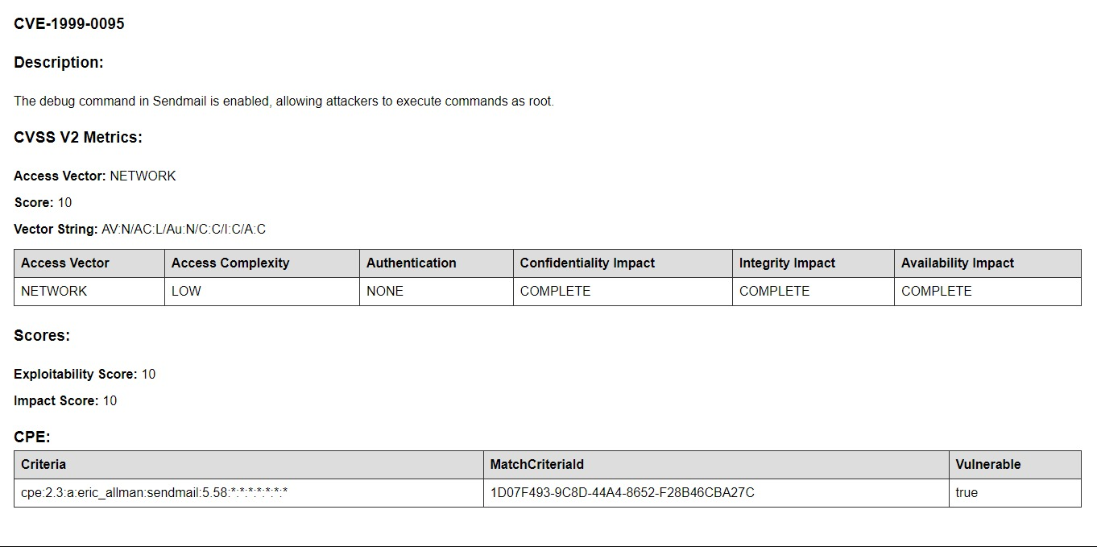

* Design and implementation of the detailed CVE page layout, incorporating rich multimedia elements and interactive components.
* Integration of real-time data fetching mechanisms to ensure up-to-date information on CVE entries.

**Synchronization process:** **sync_cve_data.py**

* **API Data Retrieval**: Developed a function to fetch Common Vulnerabilities and Exposures (CVE) data from the National Vulnerability Database (NVD) API using the **requests** library in Python.
* **Data Cleaning**: Implemented a function to clean the retrieved CVE data by removing duplicates and filtering out entries with null or missing values.
* **Database Synchronization**: Created a script to synchronize the cleaned CVE data to a MongoDB database, ensuring data integrity and consistency.
* **MongoDB Integration**: Utilized the **pymongo** library to establish a connection to the MongoDB database and perform operations such as insertion and updating of CVE data.
* **Automated Synchronization Process**: Orchestrated the synchronization process by defining a main function that coordinates the data retrieval, cleaning, and database synchronization steps.

**Outcome:**

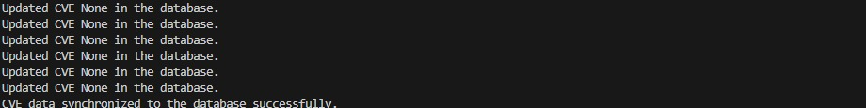

**Cleaning of the data: data_cleansing.py**

**Purpose:**

* The clean_cve_data function serves a crucial role in ensuring data quality and integrity within the CVE dataset.
* By removing duplicates and filtering out entries with missing values, it enhances the reliability and usability of the data for subsequent analysis or presentation.
* This process aids in minimizing redundancy and optimizing the efficiency of downstream data processing tasks.
* Additionally, the function contributes to maintaining a clean and organized dataset, facilitating smoother data management and interpretation.

**Output:**



**Why this Approach:**

**1.Description:**

With Flask as the chosen framework, the dynamic CVE data retrieval approach enhances user interaction by providing real-time, detailed information on specific Common Vulnerabilities and Exposures (CVE) entries.

**2.JavaScript Functionality:**

At the core of this approach lies a meticulously crafted JavaScript function responsible for fetching comprehensive CVE data from the Flask API. Seamlessly integrated with the Flask backend, this function dynamically updates the content of the detailed CVE page based on the CVE ID passed from the main page HTML. Leveraging asynchronous communication through AJAX, the function initiates requests to the Flask API endpoint, fetching the necessary CVE data. Upon successful retrieval, it dynamically populates relevant HTML elements on the detailed CVE page, including the title, description, severity, and any additional pertinent information.

**Conclusion:**

Despite encountering challenges related to data volume and technical constraints, significant progress has been made in fetching, storing, and presenting CVE data. Moving forward, efforts will focus on addressing remaining tasks such as data cleansing, synchronization, and rigorous testing to deliver a robust and dependable solution.